Group 5 members:

* Asley Butler
* Jeremy Walz
* Sarah Melton
* Sebastian Andrade Guanoquiza
* Thao Pham

CS445-01 11965 Software Engineering

Dr. Mario Guimaraes

October 7th, 2022

Software Requirements Specification

Content Table

I. Introduction 2

A) Purpose of this document 2

B) Scope of this document 2

C) Intended Audience 2

II. System Features & Requirements 2

A) Functional Requirements 3

B) Non-Functional Requirements 3

C) Data Dictionary 4

D) Initial User Interface (UI) Mockups1 5

III. Unified Modeling Language 6

A) Use Case Diagram & Use Case Descriptions 7

B) ER or Class Diagram 12

C) Sequence Diagram, Activity Diagram or State Transition Diagram 13

IV. Project Plan 14

A) Work Breakdown Structure (WBS) 14

B) Gantt Chart & Network Chart 15

V. Developing environment 16

Software Requirements Specification

# I. Introduction

Our project name is Social Work Portfolio Management System. The final deliverable would be an interaction system to help faculty members in the Department of Criminal Justice, Social Work, and Sociology at Southeast Missouri State University manage portfolio of social work degree students.

## Purpose of this document

Software Requirements Specification (SRS) gives an in-depth insight of Social Work Portfolio Management System by providing an overview of project, unified modelling language used, and project plan. It then is used as a reference to go further stages in software development life cycle.

## Scope of this document

This document mentions the software requirements specifications for deliver the final software system where:

_ SEMO students can submit and download their assignments

_ SEMO faculty members of Department of Criminal Justice, Social Work, and Sociology can view students’ submissions and grade their competency scores

## Intended Audience

There are three main groups of audience for this document:

_ Group 5 members of CS445-01 11965 Fall 2022 can review as a guide to work on creating the system

_ Professor of CS445-01 11965 Fall 2022 can review for further advice and evaluation

_ Faculty members of Department of Criminal Justice, Social Work, and Sociology can review to suggest how the feature can be edited to suit the requirements of the department

# II. System Features & Requirements

## Functional Requirements

1. Provide assignment submission feature

_ The system shall allow authorized users (students) to upload their assignments in doc, docx, or pdf files

_ The system shall enable users to choose one or multiple assignment files to download

_ The system shall enable users to delete and resubmit files before the due date

2. Provide detailed submission information

_ The system shall display date & time of submission

_ The system shall display who submits the assignment

_ The system shall display who grades the assignment

_ The system shall display competency score file

_ The system shall allow graders to write a comment

_ The system shall enable users to see the submission from oldest to latest or vice versa

3. Provide competency grading feature

_ The system shall enable graders to upload competency score excel file

_ The system shall enable graders to download competency score excel file

_ The system shall enable graders to delete and resubmit competency score excel file

_ The system shall enable users to view competency score excel file

## Non-Functional Requirements

1. Usability

_ The website shall provide an interface with red, white, and black as the main colors so that it matches with the SEMO website

_ The website should have contrasting background and text colors for easy visibility

_ The website shall provide the use of icons and toolbars

1. Reliability & Accessibility

_ The website navigation should be loaded no more than 30 seconds

_ The final deliverable shall be based on the web with the aim of running on web server of Southeast Missouri State University

1. Security

_ The website login allows only SEMO social work students, faculty members and chairman from Department of Criminal Justice, Social Work, and Sociology as well as SEMO administrators to gain access

_ An application may not grant access until the user creates a password syntax that it requires

_ The system shall automatically log out all customers after they leave the website

## Data Dictionary

|  |  |  |
| --- | --- | --- |
| **Column** | **Data Type** | **Description** |
| Student_name | 100 alphabetic characters | The name of the student |
| SE_Key | 8 numeric characters | Individual id for student |
| Paper | File | Paper that is submitted |
| Date | 6 numeric characters and 2 special characters | Date that the paper is submitted |
| Class | 2 alphabetic characters and 3 numeric characters | Class that the paper is for |
| Teacher | 100 alphabetic characters | Teacher that graded/submitted the paper to the database |
| Competency score | File | The score for the paper submission |

## Initial User Interface (UI) Mockups1

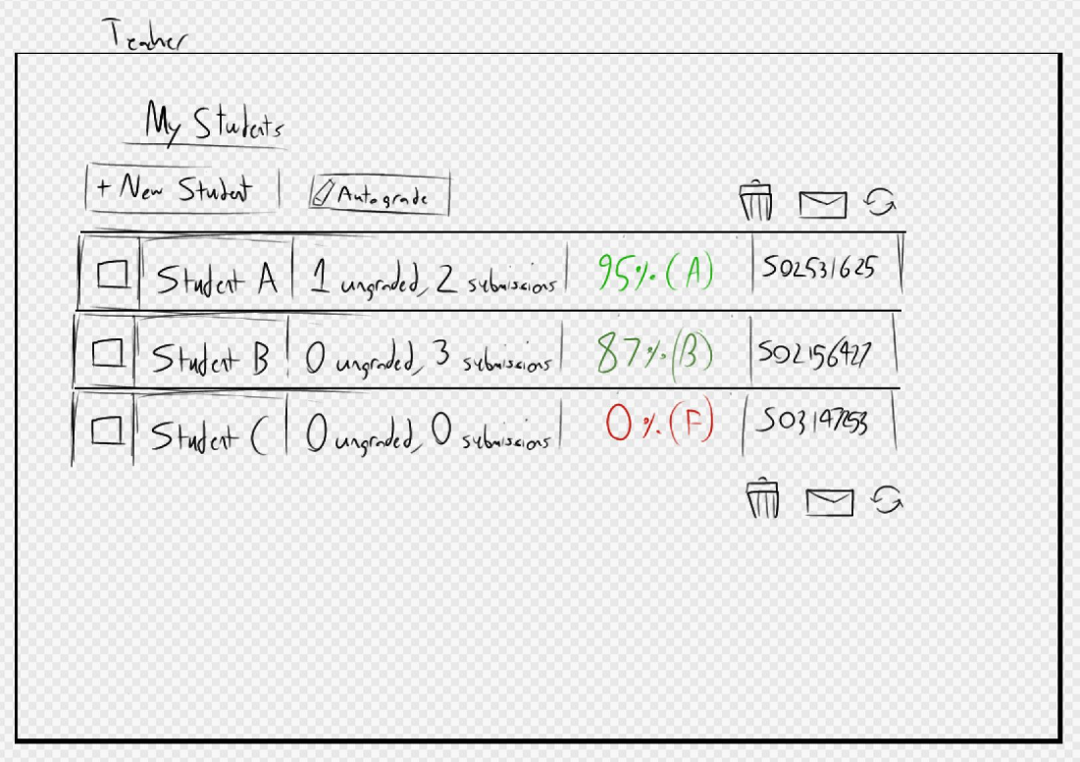

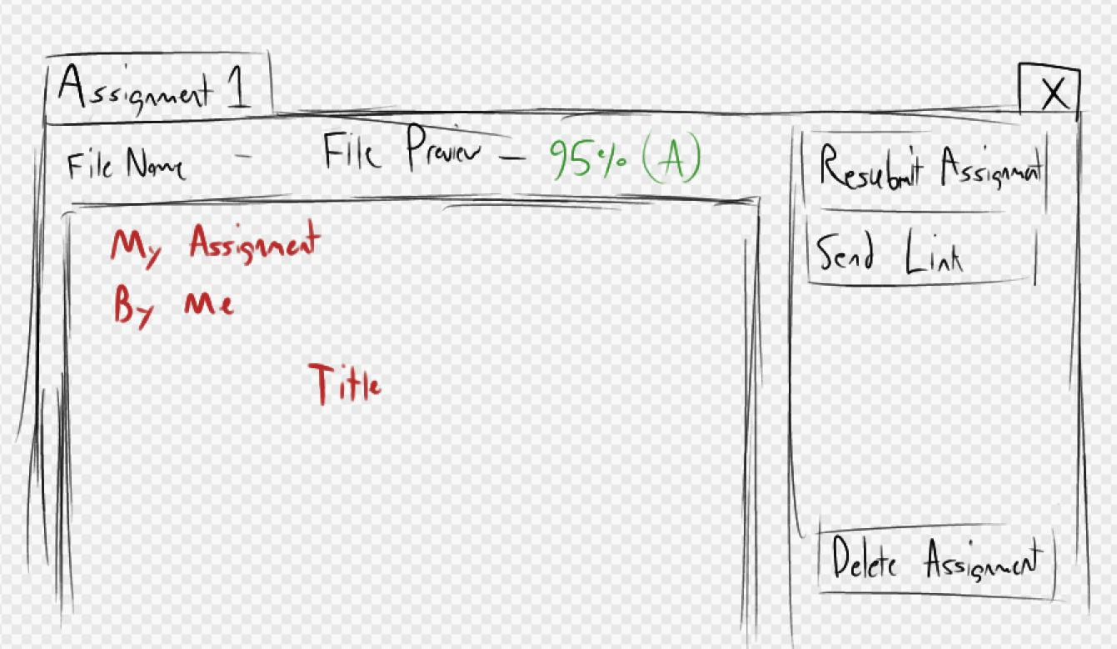

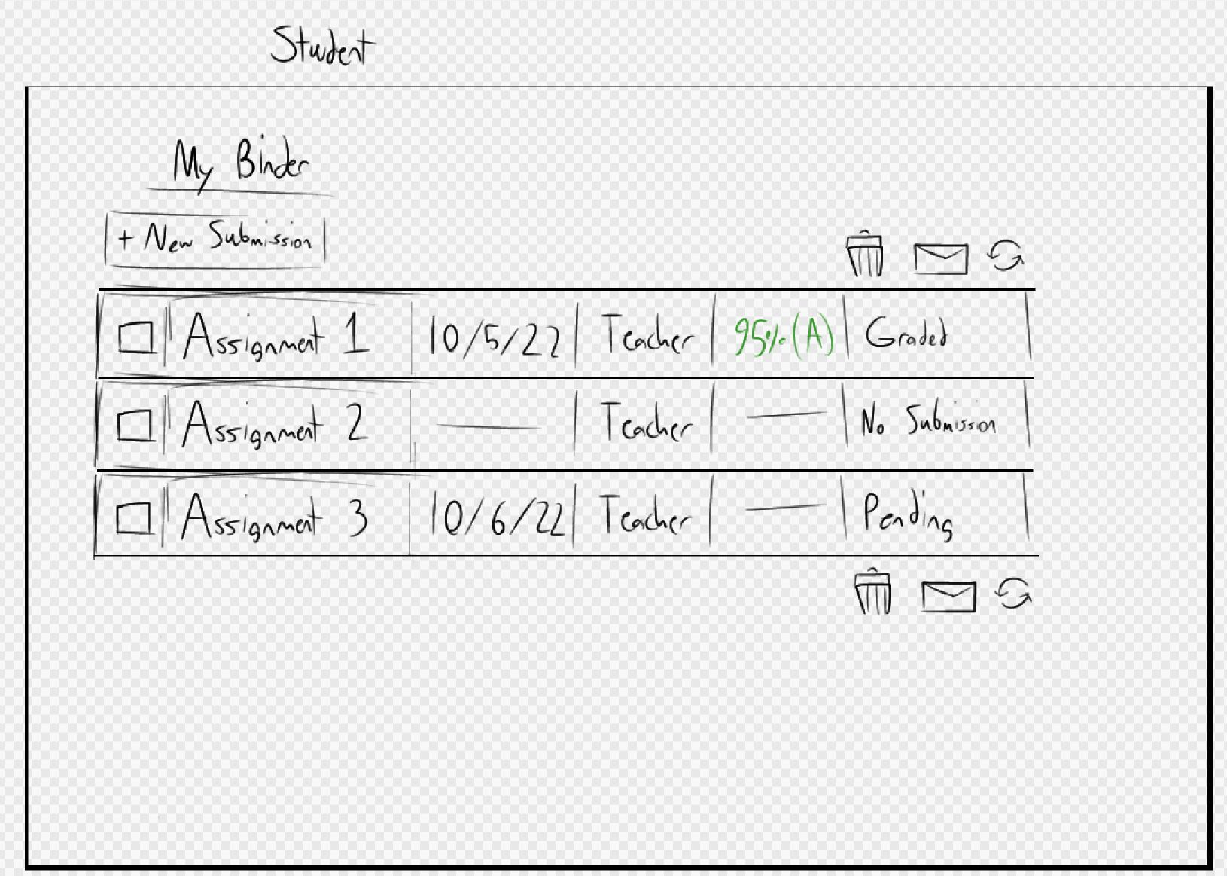

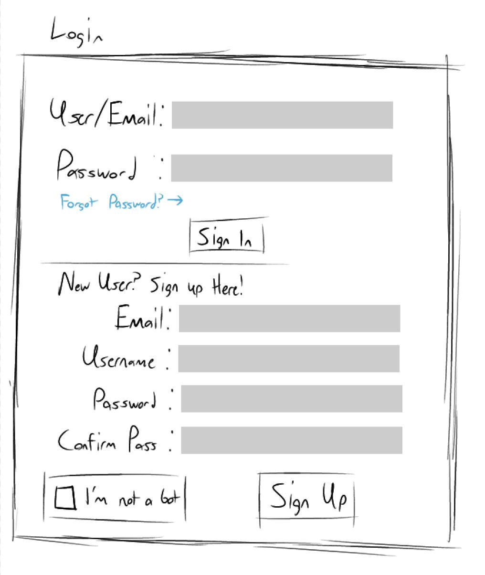

# III. Unified Modeling Language

## Use Case Diagram & Use Case Descriptions

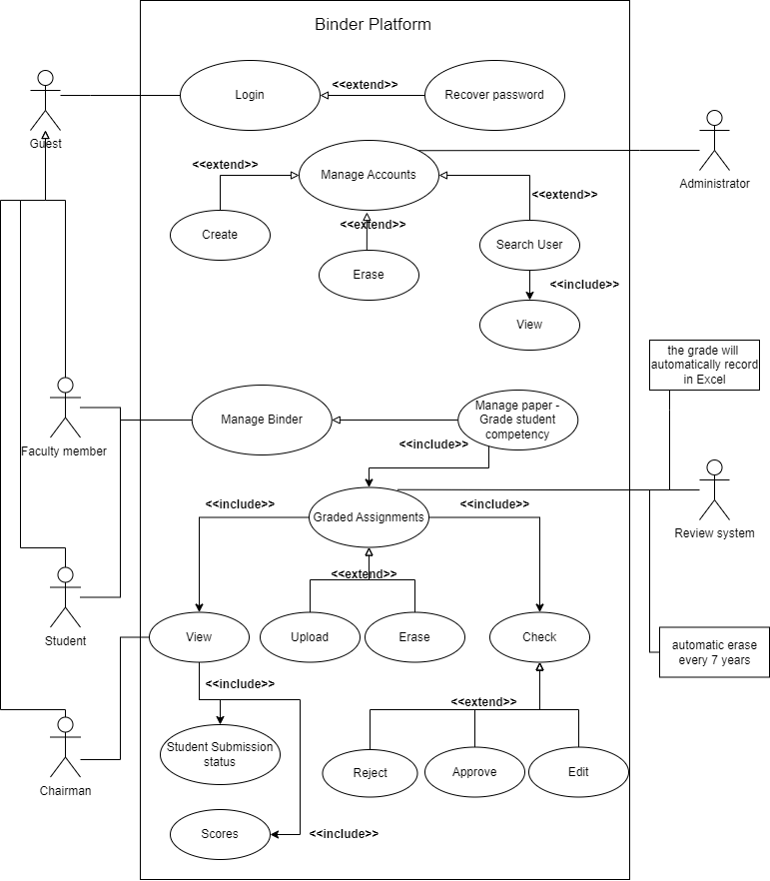

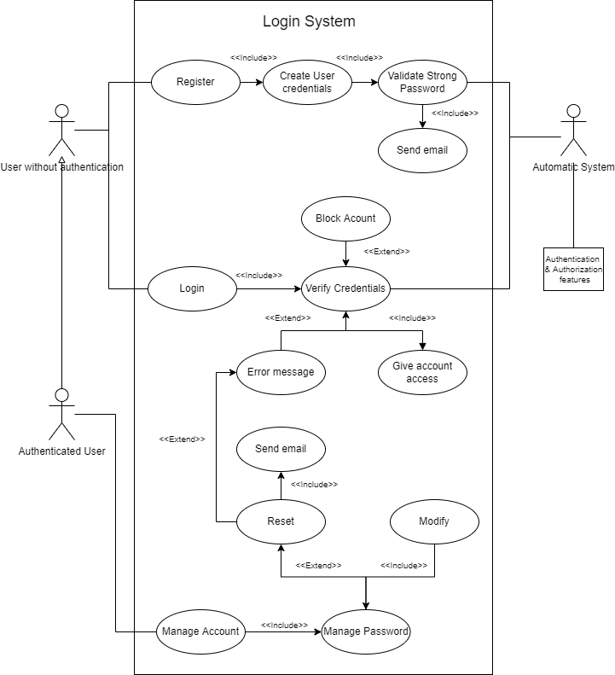

|  |  |
| --- | --- |
| **Use Case ID** | **P_01** |
| **Use Case Name** | Login |
| **Date Created** | 10/07/2022 |
| **Description** | This user case allows the user login into the system to access relevant functions according to the user roles. The roles are Faculty members, student, administrator and chairman |
| **Primary Actor** | User without authentication |
| **Secondary Actor** | None |
| **Precondition** | User must have a validated account |
| **Postcondition** | The system displays the relevant homepage |
| **Main Flow** | 1. The user enters their user and password 2. The user submits their credentials 3. The system validates the credentials 4. The system verifies the credentials 5. The system displays the user’s homepage 6. The use case ends |
| **Alternative Flow** | 3a. Missing user or password   1. The system prompts for user and password 2. Use case resumes at main flow step 1   3b Maximum 3 attempts exceeded   1. The system displays: “Maximum attempts exceeded” 2. The system locks user account 3. The use case ends   4a Invalid user or password   1. The system displays “Invalid credentials” 2. The system prompts for user and password 3. Use case resumes at main flow step 1 |

|  |  |
| --- | --- |
| **Use Case ID** | **P_02** |
| **Use Case Name** | Upload Graded Assignment |
| **Date Created** | 10/07/2022 |
| **Description** | This user case allows the user to upload their Graded Assignment for every subject. |
| **Primary Actor** | Student |
| **Secondary Actor** | Faculty member |
| **Precondition** | User must be logged in like student |
| **Postcondition** | The system displays the status of every assignment of that subject |
| **Main Flow** | 1. The user chooses the subject 2. The user chooses the assignments 3. The user clicks in upload file 4. The system charges the document 5. The user accepts that the data file is correct 6. The system changes assignment’s status 7. The system displays the assignment web 8. The use case ends |
| **Alternative Flow** | 4a. System doesn’t charge file   1. The displays “Error file doesn’t upload” 2. The system prompts for a new try 3. Use case resumes at main flow step 1   4b. The file is not the type of data required   1. The system displays: “File isn’t corresponded to this assignment” 2. The system prompts for a new try 3. Use case resumes at main flow step 1   5a Data file is not correct   1. The user clicks in cancel upload 2. The system displays “Are you agree with cancel the process” 3. The user accepts the cancel process 4. Use case resumes at main flow step 1 |

|  |  |
| --- | --- |
| **Use Case ID** | **P_03** |
| **Use Case Name** | Check Student submission status |
| **Date Created** | 10/07/2022 |
| **Description** | This user case allows the Chairman to check what is the status of each assignment in all student folders |
| **Primary Actor** | Chairman |
| **Secondary Actor** | None |
| **Precondition** | User must be logged like Chairman |
| **Postcondition** | The system displays the status of every assignment and subjects |
| **Main Flow** | 1. User enters student ID or name 2. The user chooses the subject 3. The user chooses assignment 4. The system displays the student’s assignment status and score page 5. The use case ends |
| **Alternative Flow** | 1a. Student doesn’t exist   1. The system shows “Error student doesn’t exist” 2. The system prompts for a new student ID or name 3. Use case resumes at main flow step 1 |

## ER or Class Diagram

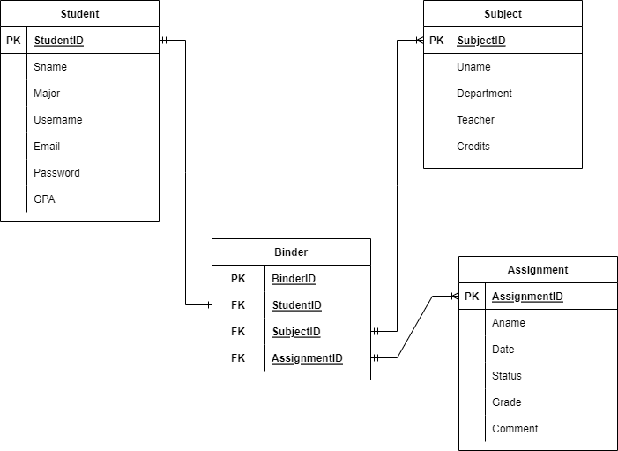

## Sequence Diagram, Activity Diagram or State Transition Diagram

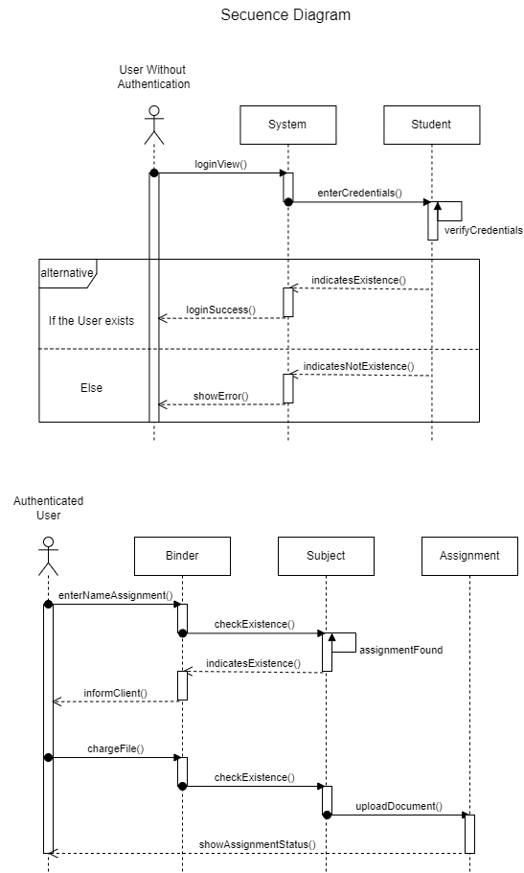

IV. Project Plan

## Work Breakdown Structure (WBS)

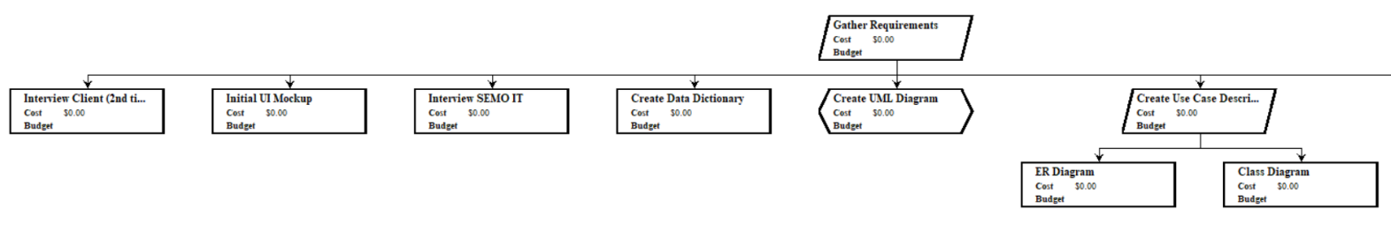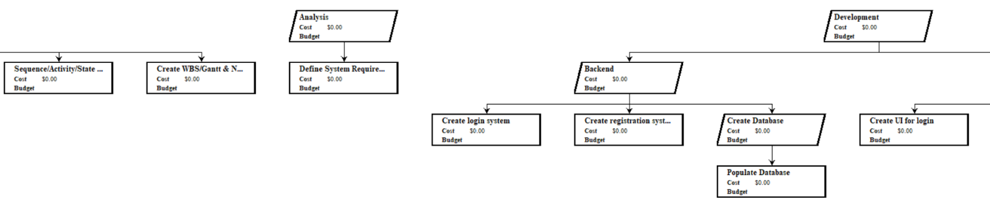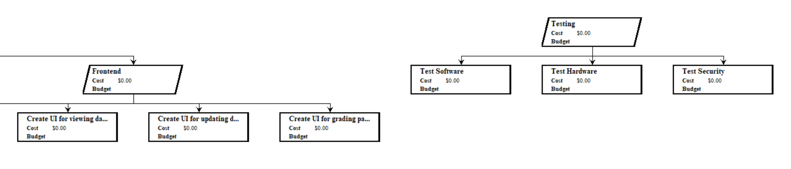

## Gantt Chart & Network Chart

Gannt Chart

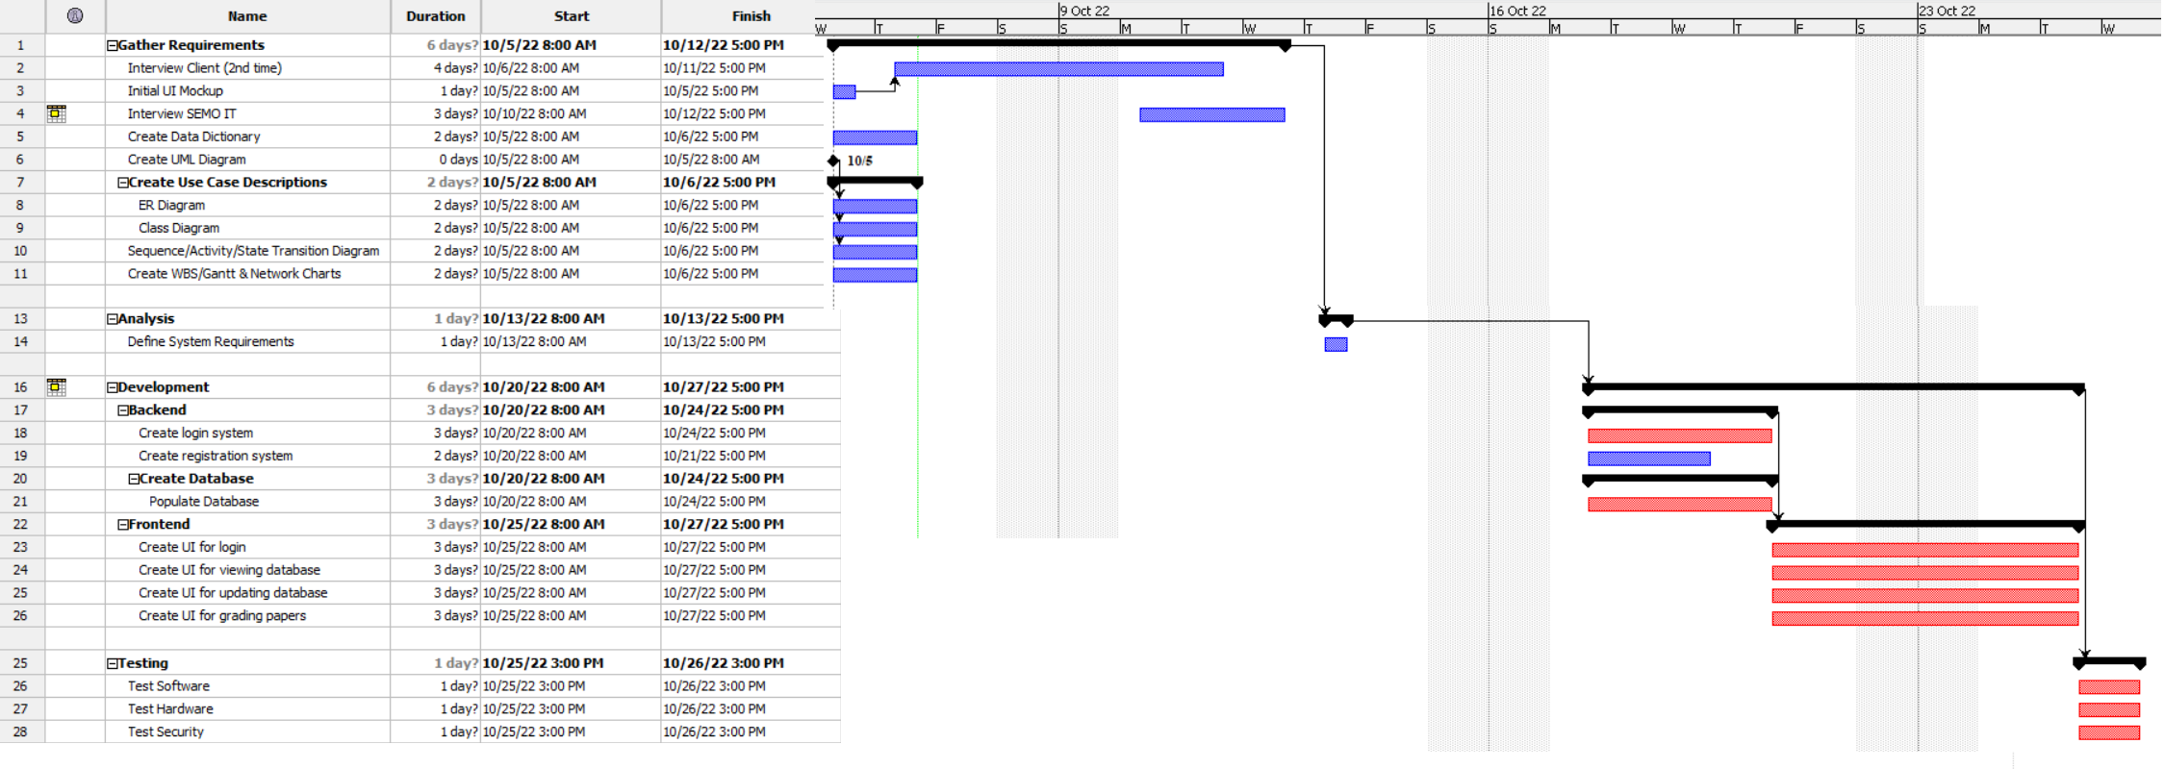

Network Chart  
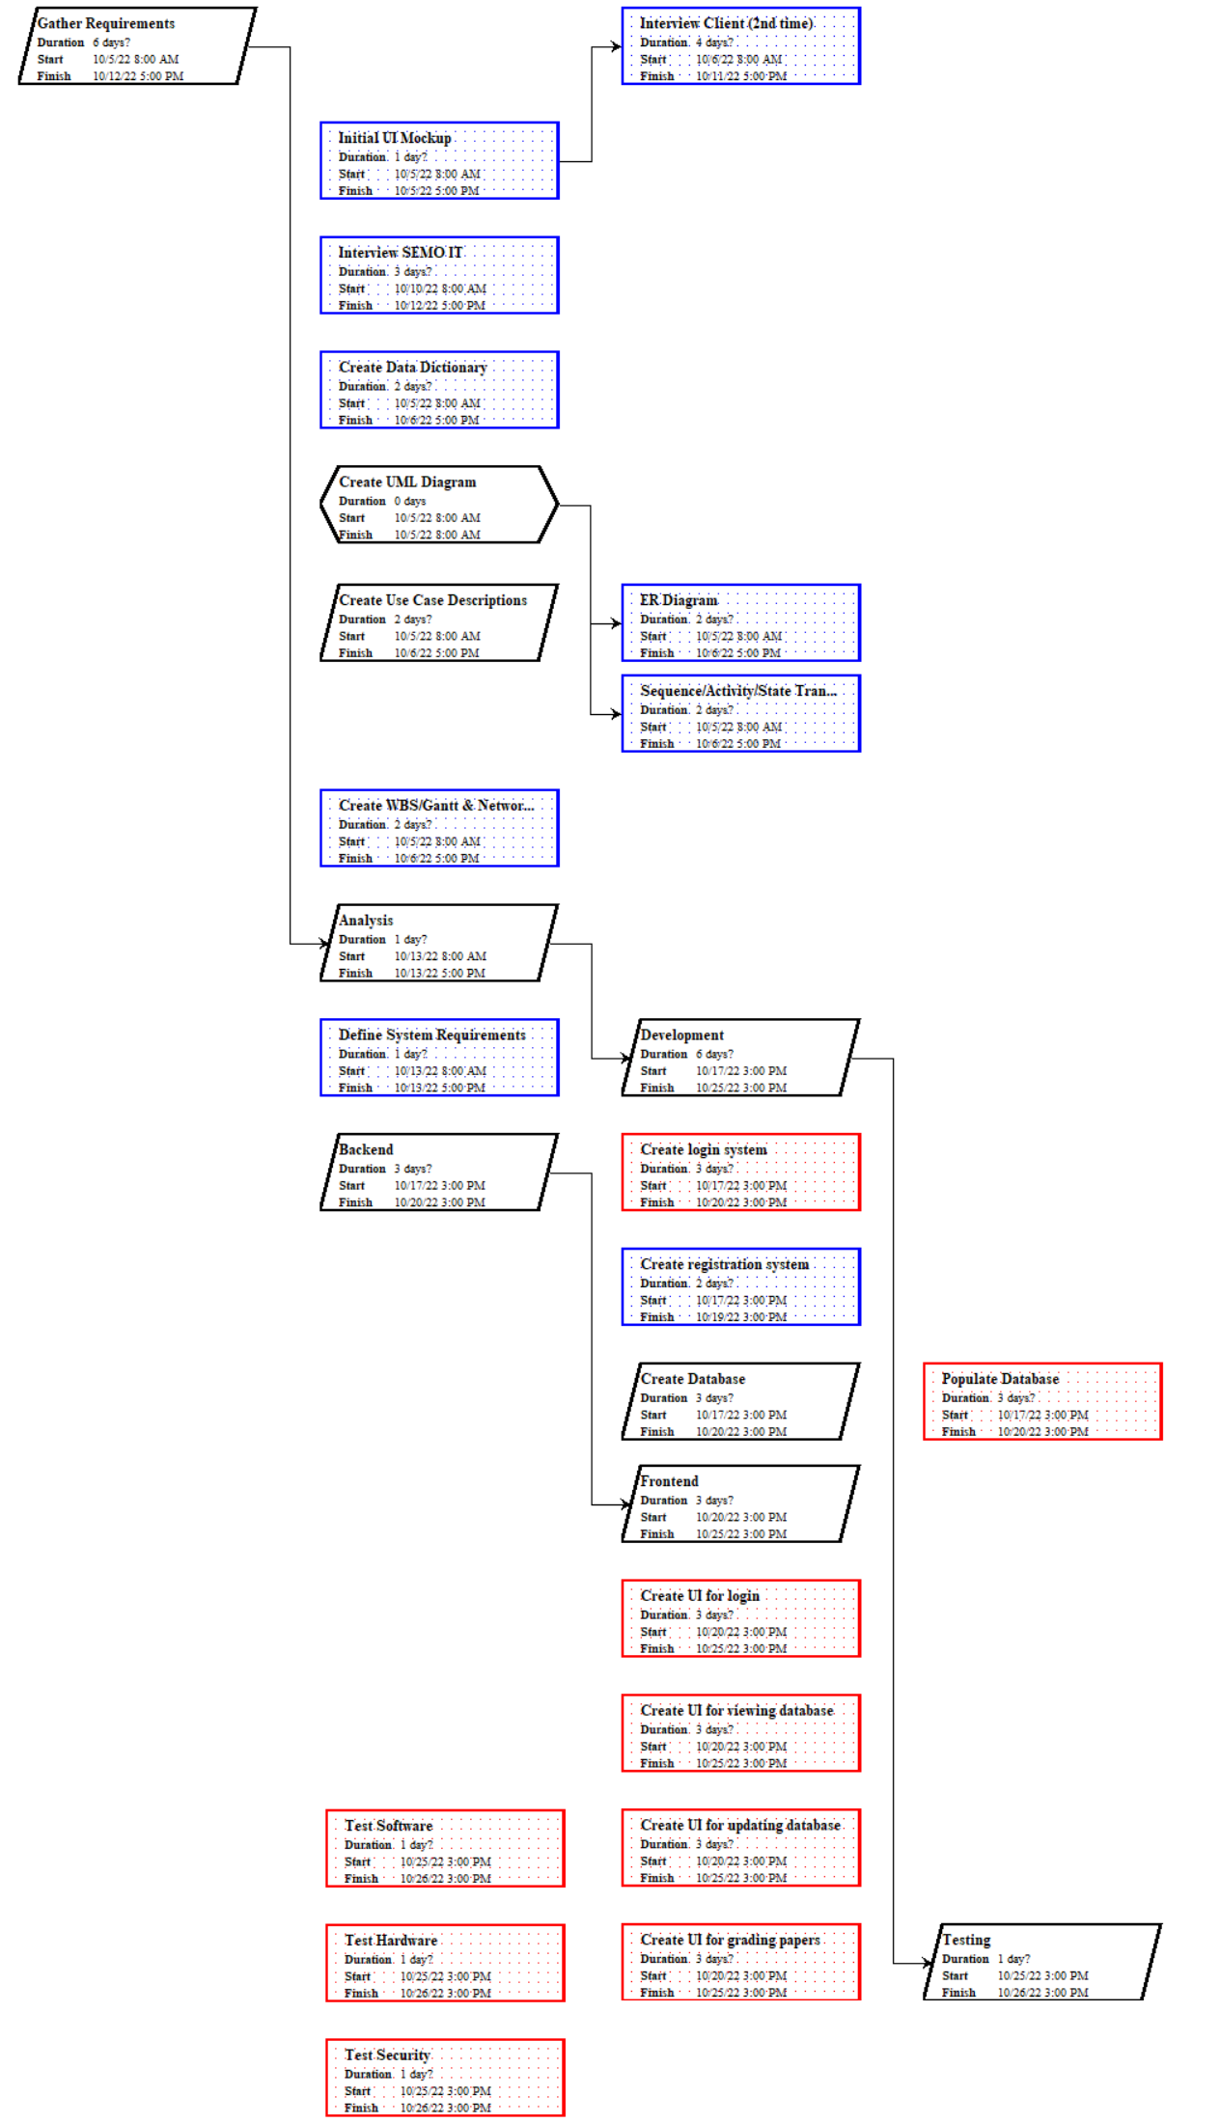

V. Developing environment

The Django framework has been chosen for the implementation of the project because it was written in Python and respects the model-view-controller design pattern. Additionally, it has handy features such as a robust database API, an extensible tag-based template system with template inheritance, and a "middleware" system for developing additional features.

